 SIMATS ENGINEERING 
Saveetha Institute of Medical and Technical Sciences
Chennai- 602105
Student Name: K. Deeksha Sree Reg. No.:192424097
Course Code: DSA0216 Slot: B
Course Name: Computer Vision with OpenCV for Moderen AI
Course Faculty: Dr. Senthilvadivu S, Dr. Kumaragurubaran T
Project Title: Vision based sign language recognisaiton using CNN
Module Photographs:
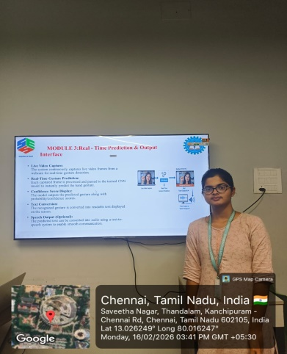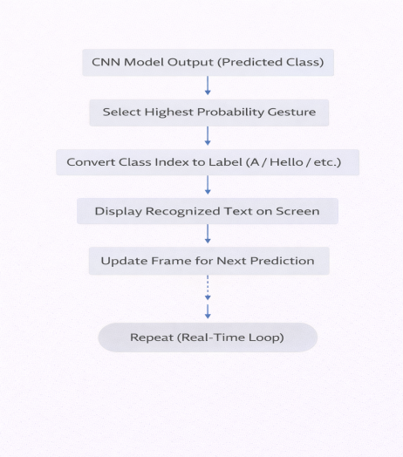

Project Description: MODULE 3-Real - Time Prediction & Output Interface
This module focuses on capturing live video through a webcam and processing each frame instantly for gesture recognition. The captured frames are preprocessed and passed to the trained CNN model, which predicts the corresponding sign in real time. The system continuously analyzes the video stream to ensure smooth and fast gesture detection without noticeable delay.
After prediction, the recognized gesture is converted into readable text and displayed on the screen along with a confidence score. Optionally, the system can also convert the predicted text into speech using a text-to-speech module. It enables effective real-time communication between hearing-impaired individuals and others by providing immediate and user-friendly output.

Student Signature Guide Signature

